**Use cases:**

**Use Case 01: Customer and Chef Registration:**

-Users download the Homey Feasts app and register by providing essential details.

- Homey Feasts ensures security through a robust vetting process for chefs.

**Use Case 02: Login:**

- Customers and chefs can easily log in using their credentials.

- Homey Feasts employs secure authentication measures for account protection.

**Use Case 03: Logout:**

- Both customers and chefs can log out, enhancing security and facilitating smooth transitions.

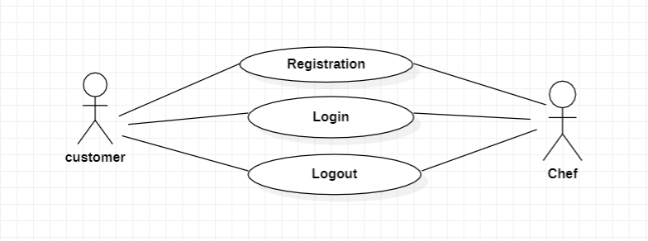

**Use Case 04: Profile Management:**

- Customers and chefs can view and edit their profiles.

- Editable details include personal information and culinary preferences.

**Use Case 05: Meal Customization for Chefs:**

- Chefs can add, edit, and delete meals.

- Added flexibility includes updating meal details, changing prices, and adjusting availability.

**Use Case 06: Interaction:**

- Customers explore chef profiles, view meal options, and place orders based on real-time information.

- Chefs maintain dynamic profiles, showcasing culinary expertise and adapting offerings to customer preferences.

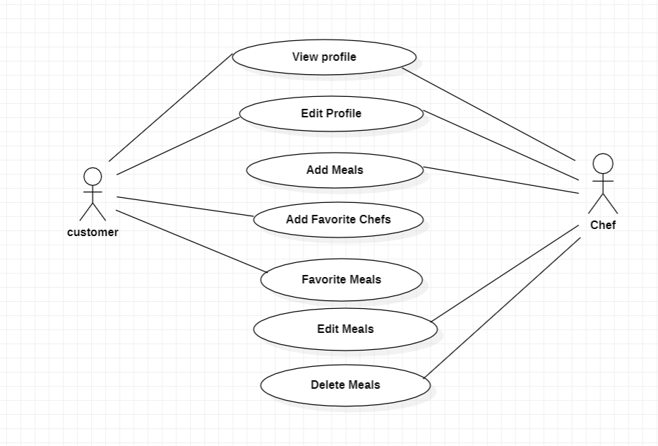

**Use Case 07: Homey Feasts - Ordering and Tracking**

**Browse Menu:**

- Customers explore a diverse menu with detailed meal descriptions.

**Add to Cart:**

- Easily select and add desired meals to the virtual cart.

**Place an Order:**

- Efficiently place orders with delivery preferences and instructions.

**Track Order:**

- Real-time tracking provides updates on meal preparation, dispatch, and delivery.

Homey Feasts ensures a seamless and transparent customer experience, from browsing the menu to tracking the delivery of delicious, homemade meals.

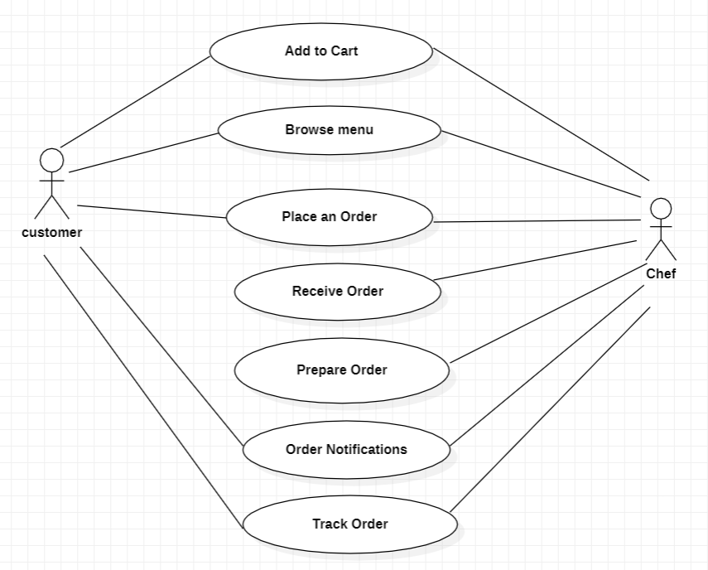

**Use Case 08: Homey Feasts - Payment, Ratings and Community Interaction**

**Make Payment:**

- Customers securely pay for meals using various methods, including Interact and debit cards.

**Checkout List:**

- Access a summary of ordered items, prices, and delivery details post-payment.

**Rating and Review:**

- Provide feedback through ratings and reviews, contributing to the Homey Feasts community.

**Use Case 09: Homey Feasts Community:**

- Seamlessly connect with other enthusiasts, share experiences, and engage in the vibrant Homey Feasts community.

Homey Feasts ensures a swift and engaging user experience, from secure payments to community interaction and feedback sharing.